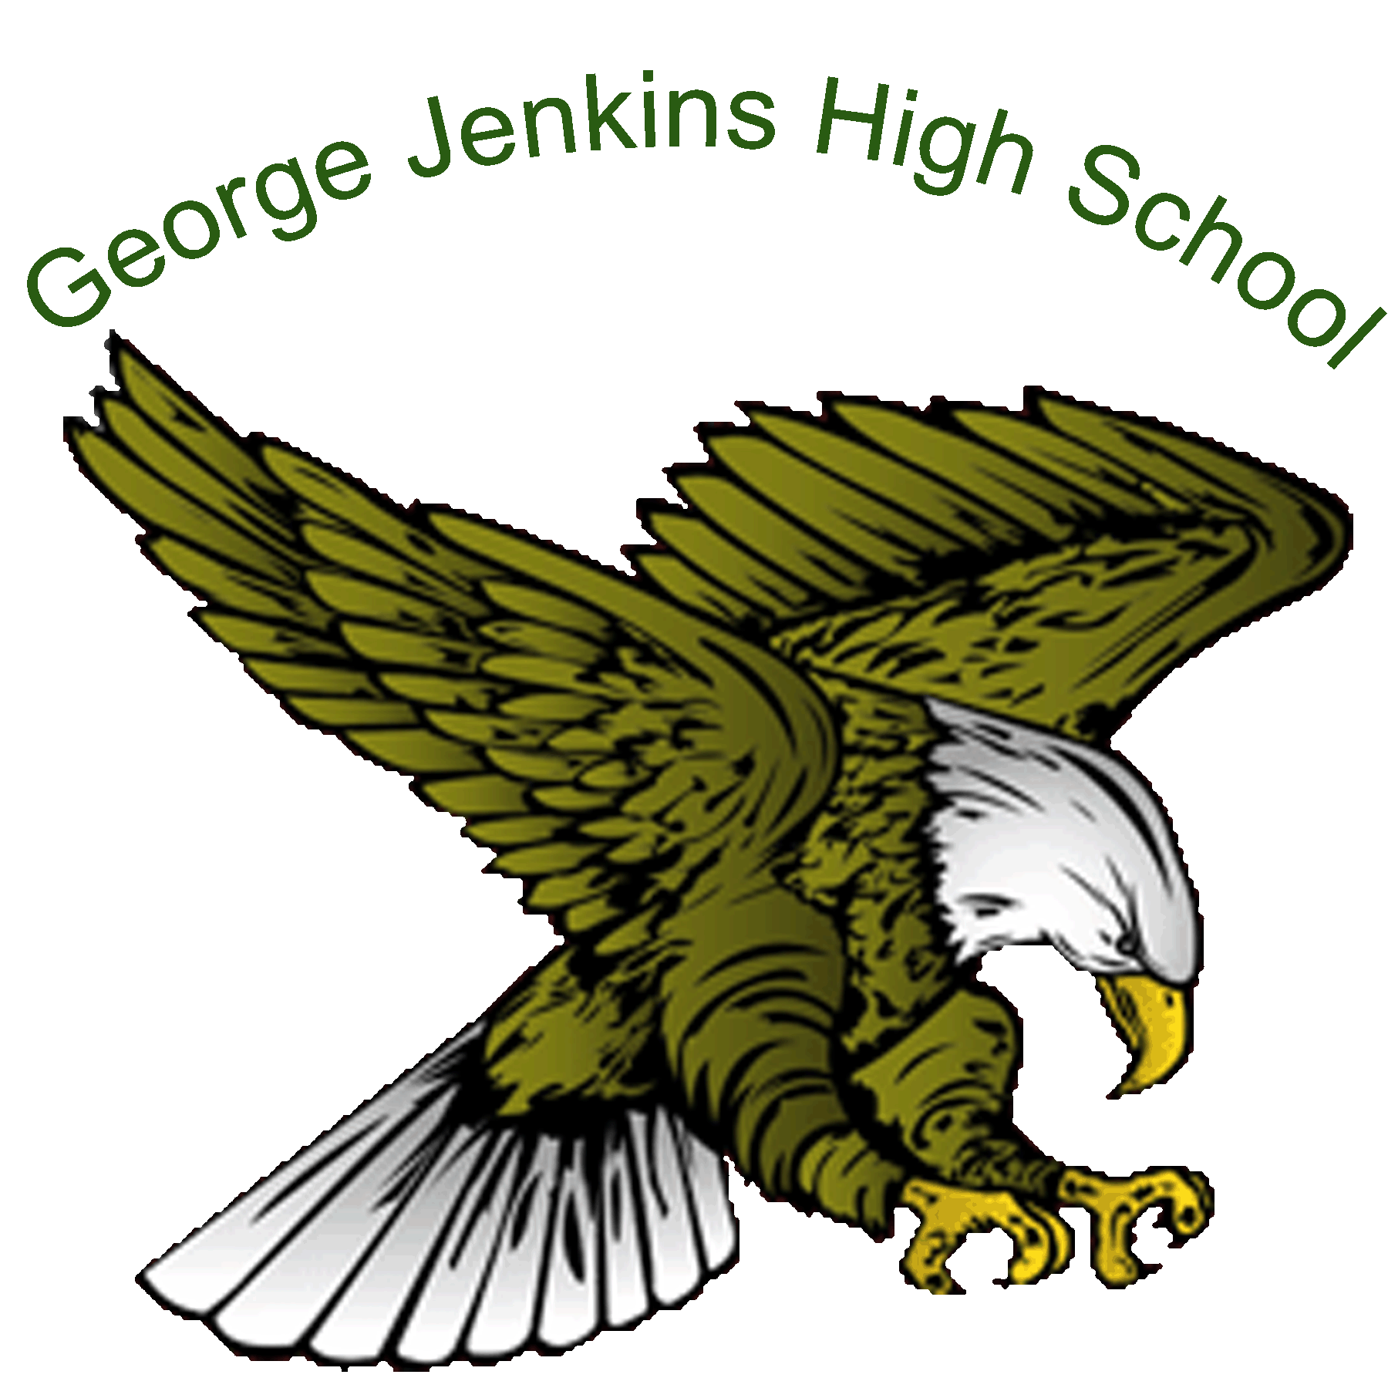
George Jenkins High School
“Dream Maker”
2020 Band Camp
Please read the entire document as there is a lot of information. There is a very important document at the end entitled: “Covid Release Form” which MUST be turned in to attend the camp. Please understand that the precautions that are being taken are for the safety of the students and to encourage your attendance. Our goal is to create a safe environment and still enjoy the wonderful experiences of the “GJHS Band”

Dates: July 20-23 9am-11am
All arrangements are based on the PCSB Phase 2 Parameters.
At this time, we can meet with a maximum of 50 students at a time and for a maximum of 2 hours TOTAL per day and ONLY outside. This includes check in, playing, breaks etc…

You MUST Immediately leave campus at 11 am
No EXCEPTIONS & No Congregating ANYWHERE on campus.
PLEASE arrange a ride if needed ahead of time

Leadership members are ONLY to attend their assigned / instrument day listed below NO EXCEPTIONS You cannot attend more than 1 day of camp.

Monday July 20: ALL Brass Instruments (Zach Parker / DM)

Tuesday July 21: All Woodwind Instruments (Nick Ballantine / DM)

Wednesday July 22: All Percussion Members

Thursday July 23: All Guard Members
Check in Procedure
Please arrive by 8:45am WITH a parent/guardian and DRIVE through the auditorium bus loop. DO NOT GET DROPPED OFF AND HAVE YOUR PARENT LEAVE. EVERYONE, EVEN IF YOU DRIVE YOURSELF, MUST HAVE A PARENT PRESENT FOR CHECK IN. Assigned approved parent volunteers will be waiting to make sure all necessary band paperwork is signed, including the COVID release form. ALL paperwork MUST be signed as you are dropped off and turned in for you to stay on campus. If you have any symptoms listed on the form, you ARE NOT to attend the event and must email Mr. LoCurcio at dennis.locurcio@polk-fl.net
When you arrive, we will check your temperature and a quick heath questioner. After that you will leave your vehicle and head to the grass area in front of the freshman academy. Line up by instrument in a straight line (6 feet apart) YOU MUST HAVE A MASK ON AND be 6 FEET APART.
Failure to comply will result in immediate dismissal.
During Camp
- We will stay outside and not enter the buildings.
- A Cloth mask must be worn at all times unless you are playing a wind instrument.
- Parents and spectators may not be at the camp.
- Alumni, siblings, ANY non-pre-approved persons etc…cannot attend
- Groups of students may not co-mingle
- Restrooms are available and may be used one student at a time if needed.

Check Out/Dismissal Procedure

At the conclusion of your assigned camp day your “ride” (if being picked up) is to pull through the bus loop and you will be dismissed to your car. THIS MUST BE AT 11 am sharp. If you cannot arrange this DO NOT ATTEND CAMP! YOU CANNOT give rides to other students unless they are a sibling. If you drive, upon dismissal you must IMMEDIATELY go to your vehicle and depart campus.
All students that own their own instrument MUST take them home.

NO LOCKERS WILL BE DISTRIBUTED THIS SCHOOL YEAR UNLESS CLEARANCE IS GIVEN.

All school owned instrument MUST stay in the Band room.

What to Bring

- Instrument (if applicable)
- Dress in shorts, t-shirt, sneakers, and cap. You may also wear sunglass.
- Do not wear pants, flip flops, boots or dark clothing. This is a safety issue and you will be sent home if not in the appropriate attire.
- Sunscreen
- Water/water Jug/container... Note students may not share anything of this nature.
- Eat a healthy meal before you arrive!
- We CANNOT provide ANY refreshments or food per CDC / PCSB guidelines
Covid Release Form
You MUST come to your assigned camp day WITH this form printed and signed.
Without this form you CANNOT stay on campus.
TO WHOM IT MAY CONCERN:
__________________________________ has my permission to participate in band activities during Phase 2 of COVID recovery at George Jenkins High School.
- As parent/guardian and student we agree to follow the listed guidelines.
1. Parents/Student answer pre-screening questionnaire prior to every band activity session.
Band Students Rehearsal Questionnaire
Students and Approved Adults must answer the questions below before being allowed to rehearse. If the answer is yes to any of the questions, the band student must not participate in any rehearsals for a 14-day period.
• Do you or have you had a fever in the last week?
• Do you or have you had a cough in the last week?
• Do you or have you had a sore throat in the last week?
• Do you or have you had a shortness of breath in the last week?
• Do you or have you had a loss of taste or smell in the last week?
• Have you been in close contact or cared for anyone diagnosed with COVID 19?
• Have you been diagnosed with COVID 19?
• Have you been in contact with anyone diagnosed with COVID 19?
• Have you traveled to a “hot spot” for COVID 19?
• Do you or have you had chills?
2. Student must have temperature taken prior to every band activity session and leave school if temperature is over 100.3°.

3. Students will bring and wear cloth face masks when not playing.

4. Students will follow all distance protocol:
Except for emergency safety considerations, students and staff must maintain at least six feet of distance from all sides.
a. When playing instruments inside, maintain 10 feet of distance from all sides. b. When outside, maintain a traditional 4-step interval (7.5 feet) from all sides. c. When not playing, students and staff must maintain at least six feet of distance from all sides and will be required to wear cloth face masks (this includes, but not limited to water breaks and moving to and from the field.)

5. Students must depart school immediately following band activity session.

6. Student agrees to follow approved adult’s safety instructions.
(For the purpose of this document, an “Approved Adult” is defined by: Any Polk County Schools employee, band director, approved volunteer, contracted band staff member (must also be registered with PCS).

Parent/Guardian name Print & Sign: ______________________________ _________________________________

Student name Print & Sign: ______________________________ _________________________________

Print name of high school: George Jenkins High School Date: July ___________, 2020

